# **Elephant Detection System**

## **Literature Review**

* Elephants in Sri Lanka:
  + There is no creature among all the beasts of the world which hath so great and ample demonstration of the power and wisdom of almighty God as the Elephant. (The History of Four-Footed Beasts, Serpents and Insects by Edward Topsell)
  + Sri Lanka has the highest density of elephants in Asia. The population of elephants in Sri Lanka is nearly 7000 (Department of Wildlife, Ministry of Agriculture - Sep 16, 2022, BBC and newsfirst.lk).
  + The Sri Lankan elephant population is now largely restricted to the dry zone in the north, east and southeast of Sri Lanka. Elephants are present in Udawalawe National Park, Yala National Park, Lunugamvehera National Park, Wilpattu National Park and Minneriya National Park but also live outside protected areas (natureodyssey.com).

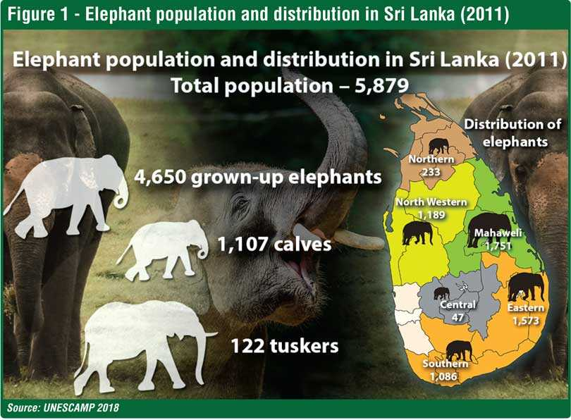

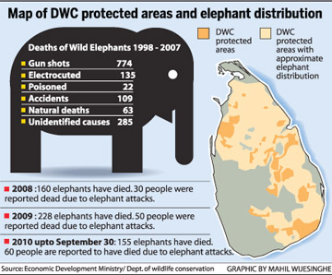

* Tourism and Elephants:
  + The island is famous for its tourism. Some of the favorite places visited by the tourists are Yala, UWNP, Pinnawala Elephant Orphanage, and the Minneriya-Kaudulla national parks (ft.lk).
  + Most importantly, the overall economic value of a single wild elephant to Sri Lanka tourism is close to Rs. 4 million or $ 21,400 (lankaenvironmentfund.org Dec 25, 2020)
  + Elephant-related tourism is worth over Rs. 1 billion or $ 5.8 million per year to Sri Lanka – over four times as much as tea! (ft.lk)
  + According to the statistics, 1,100,435 international visitors visited Sri Lanka in 2018, visited Sri Lanka’s many wildlife and national parks. Sri Lanka earned Rs. 2,138,450,422.38 in entrance fees alone especially the elephants were one of the favourite picks among them as well (ft.lk - 2018 census).

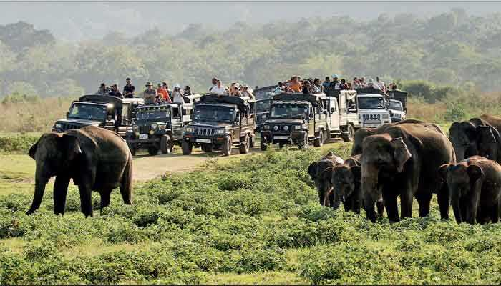

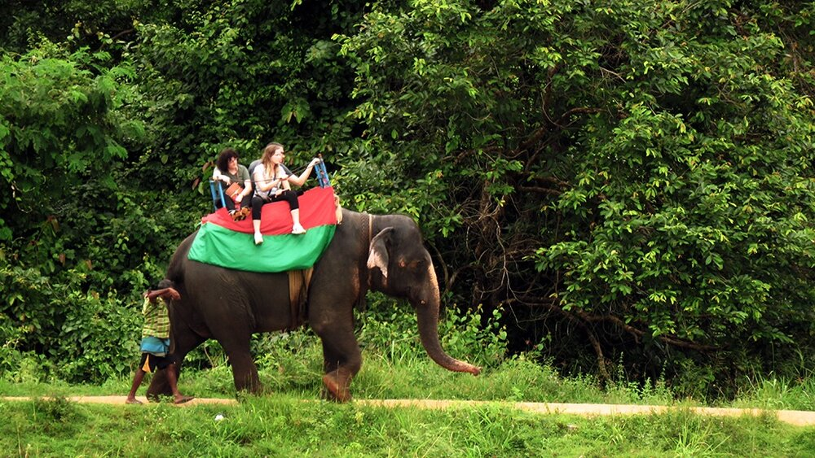

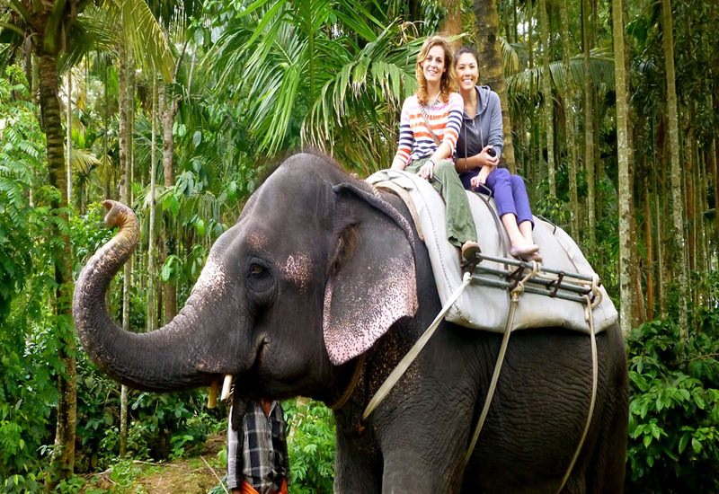

* Human-Elephant Conflict:
  + When elephants and humans interact, there is conflict from crop-raiding, injuries and deaths to humans caused by elephants, and elephants being killed by humans for reasons other than ivory and habitat degradation (Research Paper: wwf.panda.org and World Wildlife Fund)
  + However human-elephant conflicts also arise, 3,500 elephants require around 17,500 km2, or 27 percentage of the total land area while the protected areas in Sri Lanka cover only 12.5 percentage of the land area (or 8,200 km2). The lack of sufficient land area for the existence of elephants is the foremost reason for human-elephant conflicts ([ceylonexpeditions.com](http://www.ceylonexpeditions.com)).
  + A total of 112 persons were killed due to elephant attacks in 2020 (xinhuanet.com).
  + 560 officially recorded human deaths in Sri Lanka between 2010 and 2020. (Wikipedia).
  + The conflict threatens community livelihoods, and food security, and can even lead to human fatalities. The resulting economic stress to marginalized rural communities causes over $10 million in crop and property damage annually in Sri Lanka (oneearth.org).

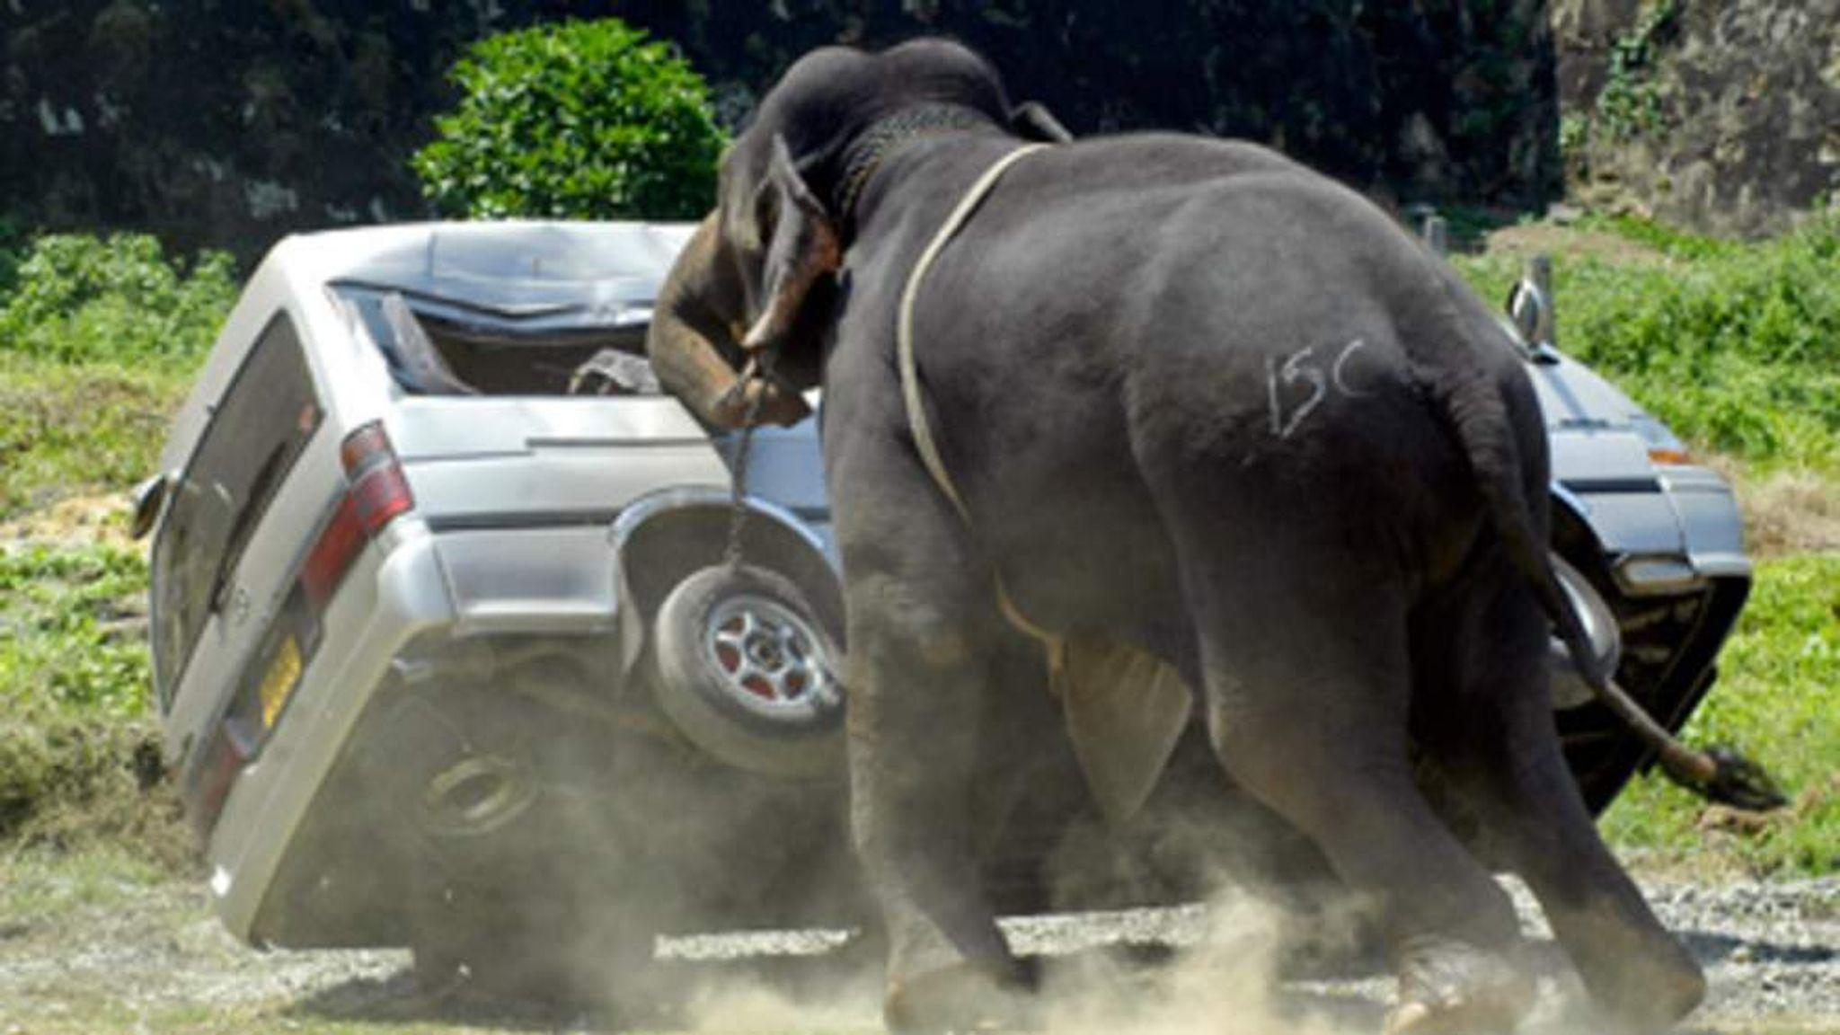



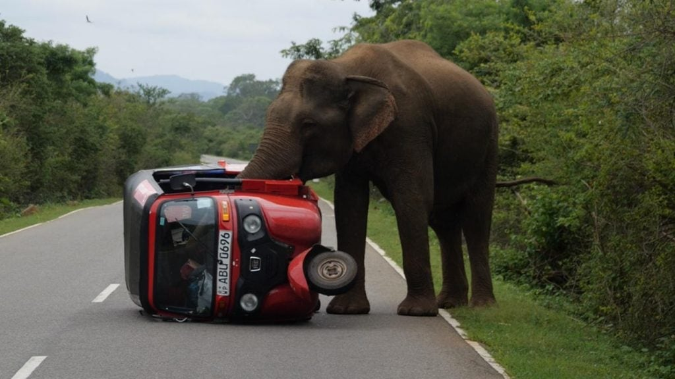

* Precluding Measures:
  + Technology is growing every single day and the evaluation of ML and AI is crucial nowadays. With the better implementation of AI, it’s possible to solve most of the past unsolved circumstances. AI is becoming hot stuff and most tech personnel express their thoughts of the future that AI is the future.
  + In addition to reducing the human-elephant conflict, AI systems were and are developed that send alerts to the villages and they can able to dread elephants before they reach the destination of the system especially the infamous buzzy bees sound that is widely used to frighten the elephants ([www.nytimes.com](http://www.nytimes.com) and kidsnews.mongabay.com).
  + AI system involves small cameras that work remotely, hidden in a tree above the reach of elephants, and when the camera’s motion sensor is triggered, it uses computer vision to detect elephants in the frame and transmits those images in near-real time to the cell phones of village guardians (WildEyes AI by NGO RESOLVE and CVEDIA).
    - The scalable, low-cost system funded in part by One Earth, uses new advances in Artificial Intelligence technology to detect elephants and transmit alerts to wildlife managers and communities to prevent conflict situations before they occur.
  + The Global Positioning System (GPS) collar system used today is another approach towards tracking elephants currently used only to identify migration patterns of elephants (Research paper: 2014 Texas Instruments India Educators' Conference by Amalinda Gamage and Malitha Wijesundara: <https://www.researchgate.net/publication/316175763_A_Solution_for_the_Elephant-Human_Conflict>).
  + Use satellite and GSM collars to track and monitor elephant movements. Collected elephant movement data is monitored with the help of AI algorithms. These software algorithms issue alert messages and facilitate rapid response if some elephants become unnaturally immobile. STE tracking app uses AI algorithms to visualize and track elephants and investigate their behaviour ( Save the Elephants project: <https://www.savetheelephants.org>)
  + AI technology that is leveraging machine learning with drones and cameras to stop poaching problems in Africa. Neurala’s AI-powered software can process terabytes of video data in real-time captured by drones. The software uses deep learning neural networks, a subset of artificial intelligence, to track and predict the movement patterns of elephants and other animals. It can also identify unknown vehicles and poachers day and night. Neurala software assists human analysts with its data-crunching potential powered by AI algorithms (Neurala’s AI: <https://www.neurala.com>).

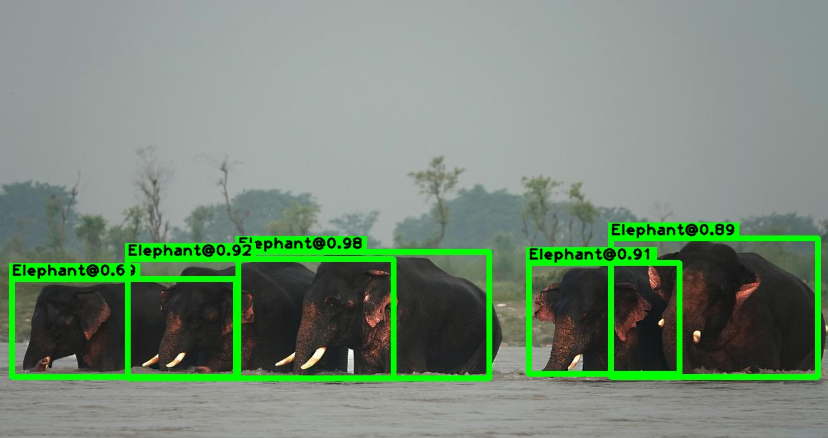

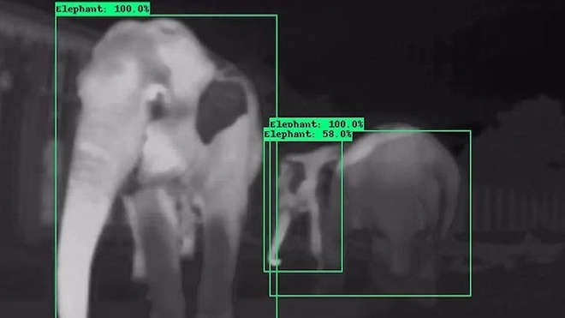

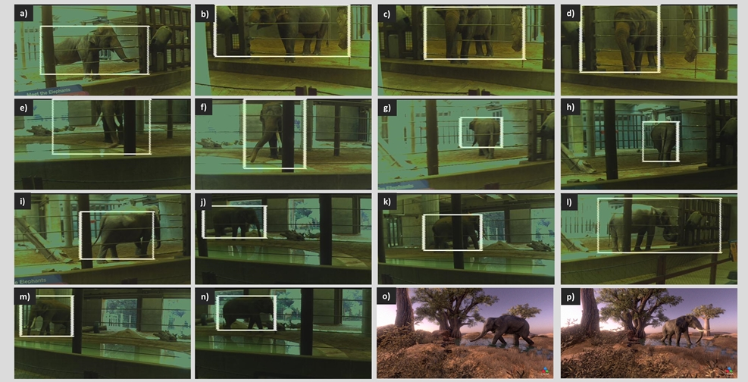

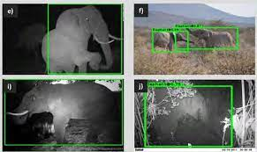

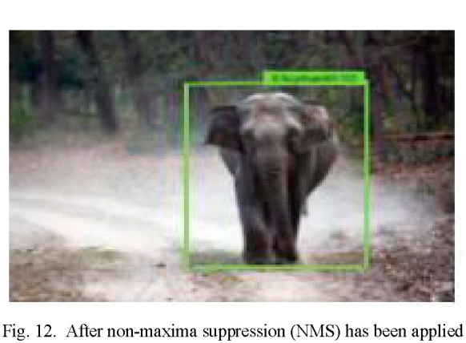

* Computer Vision:
  + Computer vision is an interdisciplinary scientific field that deals with how computers can gain a high-level understanding from digital images or videos. From the perspective of engineering, it seeks to understand and automate tasks that the human visual system can do (Wikipedia)
  + Computer vision is a field of artificial intelligence (AI) that enables computers and systems to derive meaningful information from digital images, videos and other visual inputs — and take actions or make recommendations based on that information. If AI enables computers to think, computer vision enables them to see, observe and understand (IBM: <https://www.ibm.com/topics/computer-vision>)
  + Replicating parts of the complexity of the human vision system and enabling computers to identify and process objects in images and videos in the same way that humans do. Until recently, computer vision only worked in a limited capacity. With the advances in artificial intelligence and innovations in deep learning and neural networks, the field has been able to take great leaps in recent years and has been able to surpass humans in some tasks related to detecting and labelling objects (Ilija Mihajlovic: https://towardsdatascience.com/everything-you-ever-wanted-to-know-about-computer-vision-heres-a-look-why-it-s-so-awesome)
  + In computer vision, we're trying to do the inverse, i.e to describe the world that we see in one or more images and to reconstruct its properties, such as shape, illumination, and colour distributions. It is amazing that humans and animals do this effortlessly, while computer vision algorithms are so error-prone. People who have not worked in the field often underestimate the difficulty of the problem. This misperception that vision should be easy dates back to the early days of Artificial Intelligence when it was initially believed that the cognitive (logic proving and planning) parts of intelligence were intrinsically more difficult than the perceptual components (Boden: Source: Computer Vision: Algorithms and Applications by Richard Szeliski).
  + ‘You only look once’(YOLO), is an object detection algorithm that divides images into a grid system. Each cell in the grid is responsible for detecting objects within itself. YOLO is one of the most famous object detection algorithms due to its speed and accuracy (<https://github.com/ultralytics/yolov5> by Glen Jocher and <https://medium.com/what-is-artificial-intelligence/the-yolov4-algorithm-introduction-to-you-only-look-once-version-4-real-time-object-detection-5fd8a608b0fa> reference by Louis Bouchard).
  + Computer vision as a field is an intellectual frontier. Like any frontier, it is exciting and disorganized, and there is often no reliable authority to appeal to. Many useful ideas have no theoretical grounding, and some theories are useless in practice; developed areas are widely scattered, and often one looks completely inaccessible from the other. Nevertheless, we have attempted in this book to present a fairly orderly picture of the field (Computer Vision: A Modern Approach by D. Forsyth, J. Ponce).

